Name: Andre Freeman

Student ID: 410521320

Date: Jan 20th 2018

Professor: 吳秀陽 Shiow-Yang Wu

School: National Dong Hwa University

Class: Database System, Fall 2017

**St. Christopher and Nevis Government Employee Management System**



# Table of Contents

Contents

Table of Contents 2

Problem Definition 3

Project Description 4

Requirements 5

EERD – Enhanced Entity Relationship Diagram 6

Database Schema 7

Database MySQL Schema 9

Website API Interface 18

Problems/Challenges 19

Conclusion 20

# Problem Definition

A developing country is computerizing its data storage and retrieval system. You are required to produce a solution that will enable the government to digitize and store ancient records of all the employees of the various departments and government offices. Making queries, adding new and modifying records have become a tedious task and can no longer be executed in an efficient fashion. The government wants to manage, monitor and maintain specifics about the workers because no data of the sort is kept in offices (on hand). Any time information is required a small survey has to be carried out to collect the info. Whenever basic information is required it always takes a long time and requires going to the specific department and government offices and doing it manually and independently. A solution is needed that should be able to:

1. Combine and unify all Government Employee’s Information into a central system
2. Efficiently and quickly query, modify, add or delete new records (information, employees, etc.…)
3. Manage user privileges and credentials to protect employee’s personal information.
4. Create a system that will allow other aspects can be implemented or added easily in the system.

# Project Description

The Government of St. Christopher and Nevis requires us to start the SKNGOV Database system by first creating the SKNGOV Employee Project (i.e. aspect of the database that focuses on monitoring its employees). The SKNGOV Employee Project would consist of front and back end applications that would allow storing updating and manipulating of data. MySQL will operate on the back end while webpages will provide the front end interface with PHP as the API functioning between both front and back end. With HTML (webpages) as front end beautification, accessibility, usability can easily be incorporated using CSS, JavaScript, JQuery, AJAX, etc.…

# Requirements

SKNGOV Employee Project is required to have the following requirements:

Employee

* First Name, Middle Name, Other Names
* Date of Birth, Place of Birth
* Height, Race, Blood Type, Eye color
* Address (Street, Address, City, Parish, Island, Telephone number)
* Cell Phone number, Email
* Position, Department/Government Offices Assigned to
* Appointed/Elected (For Ministry Officials)
* Payment (Salary) Based on scale system

Department

* Department Name
* Location (Street, Address, City, Parish, Island, Telephone number)
* Department Manager, Workers
* Department types

Government Offices

* Office/Ministry Name
* Minister Responsible, Permanent Secretary Assigned
* Office Location (i.e. Island)

Credentials

* Username
* Password

EERD – Enhanced Entity Relationship Diagram

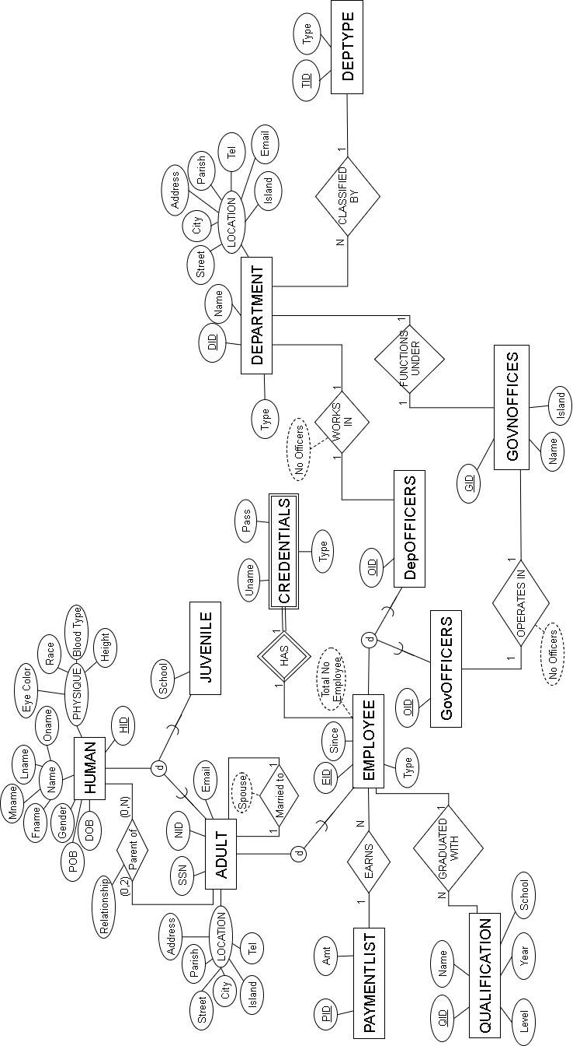

# Database Schema

GOVNOFFICES

|  |  |  |
| --- | --- | --- |
| GID | Name | Island |

DEPTYPE

|  |  |
| --- | --- |
| TID | Type |

DEPARTMENT

|  |  |  |  |  |  |  |  |  |  |
| --- | --- | --- | --- | --- | --- | --- | --- | --- | --- |
| DID | GID | Name | Type | Address | Street | City | Parish | Island | Tel |

PAYMENTLIST

|  |  |
| --- | --- |
| PID | Amt |

HUMAN

|  |  |  |  |  |  |  |  |  |  |  |  |
| --- | --- | --- | --- | --- | --- | --- | --- | --- | --- | --- | --- |
| HID | Fname | Mname | Lname | Oname | Gender | DOB | Height | Race | Eye_Color | BType | POB |

ADULT

|  |  |  |  |  |  |  |  |  |  |  |
| --- | --- | --- | --- | --- | --- | --- | --- | --- | --- | --- |
| HID | SSN | NID | Address | Street | City | Parish | Island | H_Tel | C_Tel | Email |

PARENTOF

|  |  |  |
| --- | --- | --- |
| HID | CID | Relationship |

JUVENILE

|  |  |
| --- | --- |
| HID | School |

SPOUSE

|  |  |
| --- | --- |
| HID | SID |

EMPLOYEE

|  |  |  |  |  |  |
| --- | --- | --- | --- | --- | --- |
| EID | HID | PID | Super_ID | Type | Since |

CREDENTIALS

|  |  |  |  |
| --- | --- | --- | --- |
| EID | Uname | Pass | Type |

QUALIFICATION

|  |  |  |  |  |  |
| --- | --- | --- | --- | --- | --- |
| QID | EID | Qname | Qlevel | Qyear | Qschool |

GovOFFICERS

|  |  |  |  |
| --- | --- | --- | --- |
| EID | OID | APNT | GID |

DepOFFICERS

|  |  |  |
| --- | --- | --- |
| EID | OID | DID |

# Database MySQL Schema

##CREATED BY: Andre Freeman##

##Date created: Jan 1st 2018##

##LAST Modified: Jan 24th 2018##

##St. Kitts and Nevis Government SCHEMA##

CREATE DATABASE GOVN;

USE GOVN;

CREATE TABLE GOVNOFFICES(

GID INT AUTO_INCREMENT, #Governemnt Office ID

Name VARCHAR(75), #Government Office Name

Island VARCHAR(25), #Government Office Location

PRIMARY KEY (GID)

);

#########################################################################

CREATE TABLE DEPTYPE(

TID INT AUTO_INCREMENT, #Division Type ID

Type VARCHAR(25) UNIQUE, #Division Type

PRIMARY KEY (TID)

);

#########################################################################

CREATE TABLE DEPARTMENT(

DID INT AUTO_INCREMENT, #Division ID

GID INT, #Governmet office the Division is in

Name VARCHAR(25) UNIQUE, #Division Name

Type INT, #DIVISION TYPE ID

Address VARCHAR(25), #Division Loaction

Street VARCHAR (25), #Division Loaction

City VARCHAR(25), #Division Loaction

Parish VARCHAR(25), #Division Loaction

Island VARCHAR(25), #Division Loaction

Tel INT (7),

PRIMARY KEY(DID),

FOREIGN KEY(GID) REFERENCES GOVNOFFICES(GID)

ON UPDATE CASCADE

ON DELETE RESTRICT,

FOREIGN KEY (Type) REFERENCES DEPTYPE(TID)

ON UPDATE CASCADE

ON DELETE RESTRICT

);

########################################################################################

CREATE TABLE PAYMENTLIST(

PID VARCHAR(5),

Amt DECIMAL(15,2) UNIQUE,

PRIMARY KEY(PID)

);

########################################################################################

CREATE TABLE HUMAN(

HID INT AUTO_INCREMENT,

Fname VARCHAR(25), #First Name

Mname VARCHAR(25), #Middle Name

Lname VARCHAR(25), #Last Name

Oname VARCHAR(25), #Other Name

Gender VARCHAR(1), #Gender M for Male

DOB DATE, #Date Of Birth

Height INT, #

Race VARCHAR(25), #

Eye_Color VARCHAR(25), #

BType VARCHAR (2), #BLOOD TYPE

POB VARCHAR(25), #Place of Birth

PRIMARY KEY(HID)

);

CREATE TABLE ADULT(

HID INT,

SSN INT UNIQUE, #Social Security Number

NID INT UNIQUE, #National Identification Number

Address VARCHAR(25), #Home Address

Street VARCHAR (25), #Home Street

City VARCHAR(25), #Home City/Village

Parish VARCHAR(25), #Home Parish

Island VARCHAR(25), #Home Island

H_Tel INT(7), #Home Telephone Number

C_Tel INT(7), #Cel Telephone Number

Email VARCHAR(100), #Email Address

PRIMARY KEY(HID),

FOREIGN KEY (HID) REFERENCES HUMAN(HID)

ON UPDATE CASCADE

ON DELETE CASCADE

);

###############################################################################

CREATE TABLE PARENTOF(

HID INT, #Parent ID

CID INT, #Child ID

Relationship VARCHAR(25), #Type of relationship - (Adopted) Son/Daughter

PRIMARY KEY (HID,CID),

FOREIGN KEY(HID) REFERENCES ADULT(HID)

ON UPDATE CASCADE

ON DELETE CASCADE,

FOREIGN KEY (CID) REFERENCES HUMAN(HID)

ON UPDATE CASCADE

ON DELETE CASCADE

);

###############################################################################

####################################################################################

CREATE TABLE SPOUSE(

HID INT,

SID INT UNIQUE,

PRIMARY KEY(HID),

FOREIGN KEY (HID) REFERENCES ADULT(HID)

ON UPDATE CASCADE

ON DELETE CASCADE,

FOREIGN KEY (SID) REFERENCES ADULT(HID)

ON UPDATE CASCADE

ON DELETE CASCADE

);

####################################################################################

CREATE TABLE EMPLOYEE(

EID INT AUTO_INCREMENT UNIQUE, #Employee ID

HID INT, #HUman ID

PID VARCHAR(5), #Payment ID

Super_ID INT, #Supervisor ID

Type VARCHAR(50), #Employee Type/Position

Since DATE, #Empolyee Start Work date

PRIMARY KEY(HID),

FOREIGN KEY (HID) REFERENCES ADULT(HID)

ON UPDATE CASCADE

ON DELETE CASCADE,

FOREIGN KEY (PID) REFERENCES PAYMENTLIST(PID)

ON UPDATE CASCADE

ON DELETE RESTRICT,

FOREIGN KEY (Super_ID) REFERENCES EMPLOYEE(EID)

ON UPDATE CASCADE

ON DELETE RESTRICT

);

###################################################################################

##CREDENTIALS##

CREATE TABLE CREDENTIALS(

EID INT,

Uname VARCHAR(50), #Username

Pass VARCHAR(50), #Password

Type INT, #0-Highest Level of access 4-Lowest

PRIMARY KEY(EID),

FOREIGN KEY (EID) REFERENCES EMPLOYEE(EID)

ON UPDATE CASCADE

ON DELETE CASCADE

);

##CREDENTIALS##

###################################################################################

CREATE TABLE QUALIFICATION(

QID INT, #Qualification ID

EID INT, #Employee ID

Qname VARCHAR(25), #Degree name

Qlevel VARCHAR(25), #Degree

Qyear INT, #Year degree completed

Qschool VARCHAR(100), #School in which degree was done at

PRIMARY KEY(QID),

FOREIGN KEY(EID) REFERENCES EMPLOYEE(EID)

ON UPDATE CASCADE

ON DELETE CASCADE

);

####################################################################################

###SUB CLASSES OF EMPLOYEE###

CREATE TABLE GovOFFICERS(

EID INT,

OID INT UNIQUE AUTO_INCREMENT, #Officer ID

APNT TINYINT(1) DEFAULT NULL, #0-Appointed 1-Elected

GID INT, #Govenment Office allocated

PRIMARY KEY (EID),

FOREIGN KEY (EID) REFERENCES EMPLOYEE(EID)

ON UPDATE CASCADE

ON DELETE CASCADE,

FOREIGN KEY(GID) REFERENCES GOVNOFFICES(GID)

ON UPDATE CASCADE

ON DELETE RESTRICT

);

CREATE TABLE DepOFFICERS(

EID INT,

OID INT UNIQUE AUTO_INCREMENT, #Officer ID

DID INT, #Division ID

PRIMARY KEY (EID),

FOREIGN KEY (DID) REFERENCES DEPARTMENT(DID)

ON UPDATE CASCADE

ON DELETE RESTRICT,

FOREIGN KEY (EID) REFERENCES EMPLOYEE(EID)

ON UPDATE CASCADE

ON DELETE CASCADE

);

####################################################################################

##VEIEWS##

CREATE VIEW GOFFICES AS

SELECT GOVNOFFICES.GID, GOVNOFFICES.Name AS "G_Office",(SELECT HUMAN.Fname FROM HUMAN,EMPLOYEE,GovOFFICERS WHERE EMPLOYEE.HID=HUMAN.HID AND EMPLOYEE.EID=GovOFFICERS.EID AND govofficers.GID=GOVNOFFICES.GID AND EMPLOYEE.Type LIKE "%Minister%") AS "M_Fname",(SELECT HUMAN.Lname FROM HUMAN,EMPLOYEE,GovOFFICERS WHERE EMPLOYEE.HID=HUMAN.HID AND EMPLOYEE.EID=GovOFFICERS.EID AND govofficers.GID=GOVNOFFICES.GID AND EMPLOYEE.Type LIKE "%Minister%")AS "M_Lname",(SELECT HUMAN.Fname FROM HUMAN,EMPLOYEE,GovOFFICERS WHERE EMPLOYEE.HID=HUMAN.HID AND EMPLOYEE.EID=GovOFFICERS.EID AND govofficers.GID=GOVNOFFICES.GID AND EMPLOYEE.Type="Permanent Secretary") AS "PS_Fname",(SELECT HUMAN.Lname FROM HUMAN,EMPLOYEE,GovOFFICERS WHERE EMPLOYEE.HID=HUMAN.HID AND EMPLOYEE.EID=GovOFFICERS.EID AND govofficers.GID=GOVNOFFICES.GID AND EMPLOYEE.Type="Permanent Secretary")AS "PS_Lname",GOVNOFFICES.Island FROM GOVNOFFICES;

CREATE VIEW DWView AS

SELECT DEPARTMENT.Name AS "Department",DEPTYPE.Type AS "DType",E.EID,H.Fname,H.Lname,E.Type AS "Position",PAYMENTLIST.Amt AS "Salary",E.Since,SH.Fname AS "S_Fname",SH.Lname AS "S_Lname",S.Type AS "S_Position" FROM DEPARTMENT,HUMAN AS H,EMPLOYEE AS E, EMPLOYEE AS S,HUMAN AS SH,DEPTYPE,DepOFFICERS,PAYMENTLIST WHERE H.HID=E.HID AND E.PID=PAYMENTLIST.PID AND DEPARTMENT.DID=DepOFFICERS.DID AND DepOFFICERS.EID=E.EID AND DEPARTMENT.Type=DEPTYPE.TID AND S.EID=E.Super_ID AND S.HID=SH.HID

UNION

SELECT DEPARTMENT.Name AS "Department",DEPTYPE.Type AS "DType",E.EID,H.Fname,H.Lname,E.Type AS "Position",PAYMENTLIST.Amt AS "Salary",E.Since,NULL,NULL,NULL FROM DEPARTMENT,HUMAN AS H,EMPLOYEE AS E,HUMAN AS SH,DEPTYPE,DepOFFICERS,PAYMENTLIST WHERE H.HID=E.HID AND E.PID=PAYMENTLIST.PID AND DEPARTMENT.DID=DepOFFICERS.DID AND DepOFFICERS.EID=E.EID AND DEPARTMENT.Type=DEPTYPE.TID AND E.Super_ID IS NULL;

CREATE VIEW GWView AS

SELECT GOVNOFFICES.Name AS "G_Office",EMPLOYEE.EID, HUMAN.Fname,HUMAN.Lname,EMPLOYEE.Type AS "Position",PAYMENTLIST.Amt AS "Salary",EMPLOYEE.Since FROM GOVNOFFICES,HUMAN,EMPLOYEE,GovOFFICERS,PAYMENTLIST WHERE HUMAN.HID=EMPLOYEE.HID AND EMPLOYEE.PID=PAYMENTLIST.PID AND EMPLOYEE.EID=GovOFFICERS.EID AND GOVNOFFICES.GID=GovOFFICERS.GID;

CREATE VIEW EmpPI AS

SELECT EMPLOYEE.EID,HUMAN.Fname,HUMAN.Mname,HUMAN.Lname,HUMAN.Oname,HUMAN.Gender,HUMAN.Eye_Color,HUMAN.Race,HUMAN.BType,HUMAN.Height,HUMAN.DOB,HUMAN.POB,ADULT.Street,ADULT.Address,ADULT.City,ADULT.Parish,ADULT.Island,Adult.H_Tel,ADULT.C_Tel,ADULT.Email,EMPLOYEE.Since FROM ADULT,HUMAN, EMPLOYEE WHERE HUMAN.HID=ADULT.HID AND ADULT.HID=EMPLOYEE.HID;

##################################################################################

##Server Connect EDIT##

DROP USER IF EXISTS 'lgReq'@'localhost';

CREATE USER 'lgReq'@'localhost' IDENTIFIED BY 'LG0SKN';

GRANT INSERT ON GOVN.CREDENTIALS TO 'lgReq'@'localhost';

GRANT SELECT ON GOVN.CREDENTIALS TO 'lgReq'@'localhost';

GRANT SELECT ON GOVN.HUMAN TO 'lgReq'@'localhost';

GRANT SELECT ON GOVN.EMPLOYEE TO 'lgReq'@'localhost';

GRANT SELECT ON GOVN.ADULT TO 'lgReq'@'localhost';

GRANT SELECT ON GOVN.DepOFFICERS TO 'lgReq'@'localhost';

DROP USER IF EXISTS 'TUser'@'localhost';

CREATE USER 'TUser'@'localhost' IDENTIFIED BY 'SKNG1234KNA';

GRANT SELECT ON GOVN.DWView TO 'TUser'@'localhost';

GRANT SELECT ON GOVN.GWView TO 'TUser'@'localhost';

GRANT SHOW VIEW ON GOVN.* TO 'TUser'@'localhost';

GRANT SELECT ON GOVN.EmpPI TO 'TUser'@'localhost';

GRANT SELECT ON GOVN.CREDENTIALS TO 'TUser'@'localhost';

DROP USER IF EXISTS 'SUser'@'localhost';

CREATE USER 'SUser'@'localhost' IDENTIFIED BY 'S0998KNA';

GRANT UPDATE ON GOVN.EMPLOYEE TO 'SUser'@'localhost';

GRANT UPDATE ON GOVN.HUMAN TO 'SUser'@'localhost';

GRANT UPDATE ON GOVN.GovOFFICERS TO 'SUser'@'localhost';

GRANT UPDATE ON GOVN.DepOFFICERS TO 'SUser'@'localhost';

GRANT SELECT ON GOVN.EMPLOYEE TO 'SUser'@'localhost';

GRANT SELECT ON GOVN.HUMAN TO 'SUser'@'localhost';

GRANT SELECT ON GOVN.DWView TO 'SUser'@'localhost';

GRANT SELECT ON GOVN.GWView TO 'SUser'@'localhost';

GRANT SELECT ON GOVN.EmpPI TO 'SUser'@'localhost';

GRANT SHOW VIEW ON GOVN.* TO 'SUser'@'localhost';

GRANT SELECT ON GOVN.CREDENTIALS TO 'SUser'@'localhost';

DROP USER IF EXISTS 'PUser'@'localhost';

CREATE USER 'PUser'@'localhost' IDENTIFIED BY 'P6345SKN';

GRANT ALL ON GOVN.* TO 'PUser'@'localhost';

GRANT INSERT ON GOVN.* TO 'PUser'@'localhost';

GRANT SHOW VIEW ON GOVN.* TO 'PUser'@'localhost';

GRANT UPDATE ON GOVN.* TO 'PUser'@'localhost';

GRANT DELETE ON GOVN.* TO 'PUser'@'localhost';

GRANT SELECT ON GOVN.EmpPI TO 'PUser'@'localhost';

GRANT SELECT ON GOVN.CREDENTIALS TO 'PUser'@'localhost';

DROP USER IF EXISTS 'AUserSKNGOV'@'localhost';

CREATE USER 'AUserSKNGOV'@'localhost' IDENTIFIED BY 'AKNAGov7492';

GRANT ALL ON GOVN.* TO 'AUserSKNGOV'@'localhost';

GRANT GRANT OPTION ON GOVN.* TO 'AUserSKNGOV'@'localhost';

######################################################################################

## INITIALIZATION (TEST) DATA##

INSERT INTO GOVNOFFICES (Name,Island) VALUES

("Governor General Office","St. Christopher"),

("Prime Minister Office","St. Christopher"),

("Justice And Legal Affairs","St. Christopher"),

("Agriculuture, Cooperative, Fisheries","St. Christopher"),

("Finance","St. Christopher"),

("Lands and Housing","St. Christopher"),

("Consumer Affairs","St. Christopher"),

("Information","St. Christopher"),

("Tourism and International Transport","St. Christopher"),

("National Security","St. Christopher"),

("Health","St. Christopher"),

("Public Works, Energy and Public Utilities","St. Christopher"),

("Education","St. Christopher"),

("Social ANd Community Development, Culture and Gender Affairs","St. Christopher"),

("Foreign Affairs","St. Christopher"),

("Premier's Ministry","Nevis"),

("Agriculuture, Cooperative, Fisheries, Lands and Housing","Nevis"),

("Public Works, Utilities, Transport and Ports","Nevis"),

("Education and Human Resources","Nevis"),

("Finance","Nevis"),

("Tourism","Nevis"),

("Police","Nevis");

INSERT INTO PAYMENTLIST(PID,Amt) VALUES

("K1",1040), ## K1 TO K47 Scale

("K2",1207), ## + 167

("K3",1374),("K4",1541),("K5",1708), ("K6",1875),("K7",2042),("K8",2209),("K9",2376),("K10",2543),("K11",2710),("K12",2877),("K13",3044),("K14",3211),("K15",3378),("K16",3545),("K17",3712),("K18",3879),("K19",4046),("K20",4213),("K21",4380),("K22",4547),("K23",4714),("K24",4881),("K25",5048),("K26",5215),("K27",5382),("K28",5549),("K29",5716),("K30",5883),("K31",6050),("K32",6217),("K33",6384),("K34",6551),("K35",6718),("K36",6885),("K37",7052),("K38",7219),("K39",7386),("K40",7553),("K41",7720),("K42",7887),("K43",8054),("K44",8221),("K45",8388),("K46",8555),("K47",8722);

INSERT INTO DEPTYPE(Type) VALUES

("Airport"),

("Secondary School"),

("Office"),

("Primary School"),

("Customs");

INSERT INTO DEPARTMENT (GID, Name,Type, Address, Street, City, Parish, Island, Tel) VALUES

(8,"RLB Int'l Airport",1,NULL,NULL,"Basseterre","St. Goerges","St. Christopher",4658472),

(13,"Saddlers Secondary School",2,NULL,"Upper Project","Saddlers","St. John","St. Christopher",4668493),

(13,"Cayon Secondary School",2,"Big Drain","Gadwin Street","Cayon","St. Mary","St. Christopher",4650098);

INSERT INTO HUMAN (Fname, Mname, Lname, Oname, Gender, DOB, Height, Race, Eye_Color, BType, POB) VALUES

("Andre","Urban","Freeman",NULL,"M","1994:06:21",180,"Black","Brown","A+","St. Christopher"),

("Djavan","Kayode","Martin",NULL,"M","1992:08:11",176,"Black","Brown","0+","St. Christopher"),

("Ramon","Orlando","Perez","Liantaud","M","1993:11:11",170,"Latin","Brown","B-","Cuba"),

("Evan","Catner","Gruber",NULL,"M","1997:04:20",187,"Caucasion","Blue","AB+","Kingdom of Swaziland"),

("Verno","Banana","Federick","Patrick","M","1990:01:01",167,"Black","Brown","B-","St. Lucia");

INSERT INTO ADULT (HID, SSN, NID, Address, Street, City, Parish, Island, H_Tel, C_Tel, Email) VALUES

(1,231232,565434,NULL,"Edward Street","Saddlers","St. John","St. Christopher",4656932,6606580,"andre_freeman@live.com"),

(2,4554645,6453434,"No. 46","God-Wing Street","Frigate Bay","St. George","St. Christopher",4655331,6625364,"dkm@gmail.com"),

(3,64564,456324,"No. 24","Airport Road","Newtown","St. Goerge","St. Christopher",4663433,6603434,"ramonl@aol.com"),

(4,23234,552323,"Sands Complex","High Way #27","Sandy Point","St. Anne","St. Christopher",4655869,6643492,"gruber92@live.com"),

(5,49343,96563,"Main Street","Upper Project","Cayon","St. Mary","St. Chirstopher",4659999,6603943,"VF@yahoo.com");

INSERT INTO EMPLOYEE (HID, PID, Super_ID,Type,Since) VALUES

(1,"K25",NULL,"Computer Technition","2017:12:1"),

(2,"K47",NULL,"Prime Minister","2010:01:01"),

(3,"K30",2,"Head Teacher","2018:01:01"),

(4,"K20",NULL,"Permanent Secretary","2016:05:19"),

(5,"K25",NULL,"Air Traffic Controller","2015:09:11");

INSERT INTO GovOFFICERS (EID,APNT,GID) VALUES

(2,1,8),

(4,0,8);

INSERT INTO DepOFFICERS (EID, DID) VALUES

(3,2),

(5,1);

INSERT INTO CREDENTIALS (EID,Uname,Pass,Type) VALUES

(1,"Dre","1234",0),

(3,"Rayray","rrrr",2),

(4,"Evan","EEEE",3);

# Website API Interface

With mySQL operating on the server (back-end) then need of an intractable client side (front-end) functionality is required. By using website/webpages the front would/is accessible by any user with a web browser and connected to the internet. The Website Interface consists of the following HTML webpages: (1) Homepage, (2)Login page, (3)Error message page(s) and (4)View page(s) alongside extra PHP pages to provide functionality. Attached bellowed are few screenshots

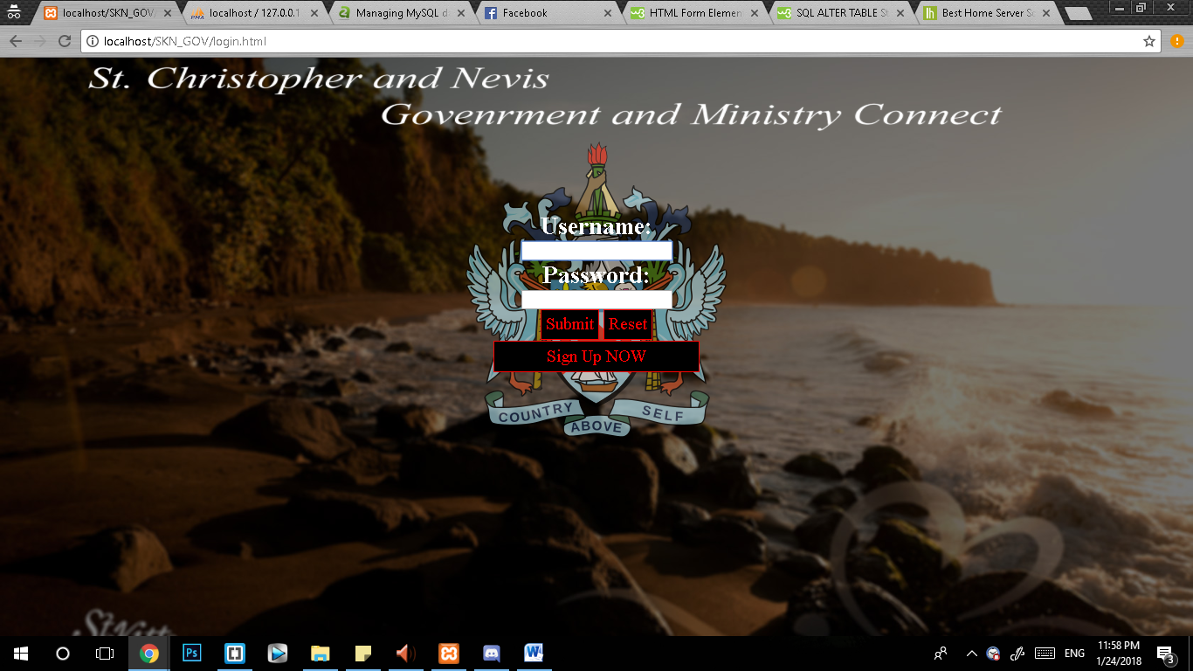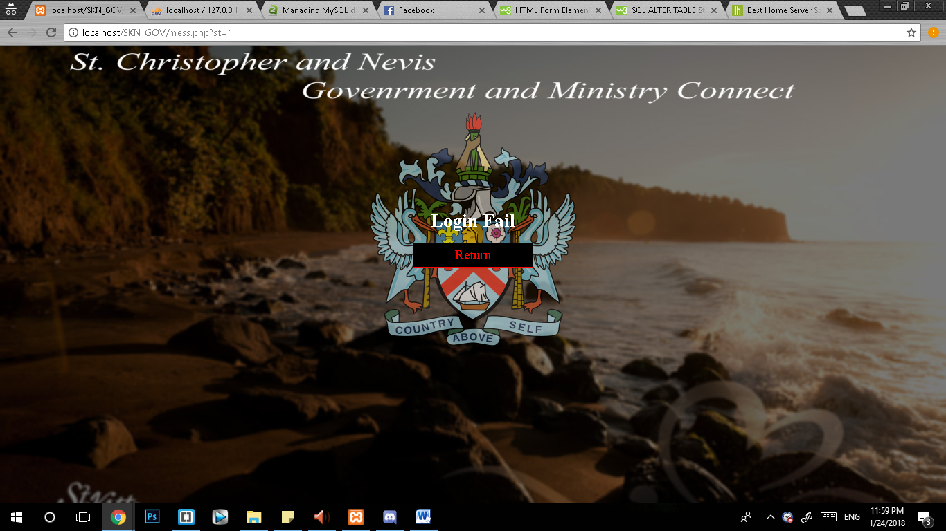

Figure 1.1-Showing login.html Figure1.2- Showing mess.php

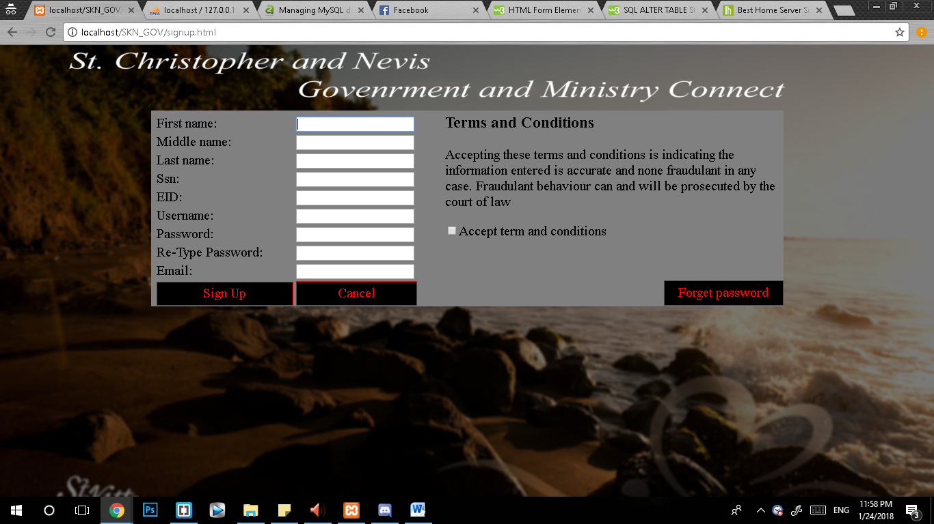

Figure 2-Showing signup.html

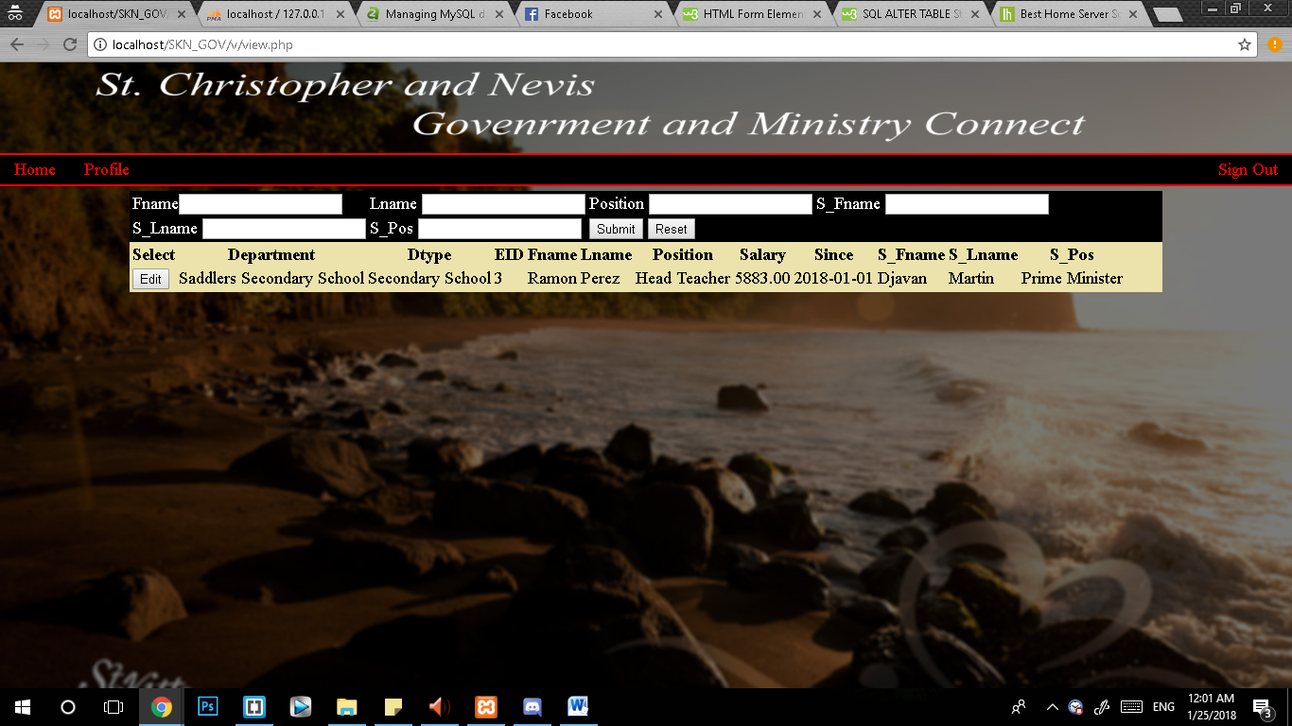

Figure 3-Showing view.php

# Problems/Challenges

At the start of this project the goal was to create a database that would span the entire government system. That is employees, social security, judiciary system, immigration, education, finance, etc…. Such a wide and vast scope would require large amounts of time to complete it. As a remedy this project tries to create a database system that would be easy to incorporate other aspects while mainly focusing on keeping track of government employees.

The issue of ISP dynamic IP addresses provided to homes also creates a semi difficult process of hosting websites online on the World Wide Web (WWW).

This database is still not complete in terms of:

1. Exact credential privileges for various type/class of users in comparison to real life.
2. Fully functional methods to switch, add, and delete Employee in GovOFFICERS and DeptOFFICERS accordingly.

# Conclusion

At this point the SKNGOV employee database project is functional and operates as it is intended. The requirements proposed are almost 100% satisfied and both front-end and back-end resonates in tune. This project has been a fun and exciting experience and the full completion of this project is inevitable.